Parent Pick Up :

* Notify the school that your child will be parent pick up.
* Walk to the East Entrance to pick up your student.

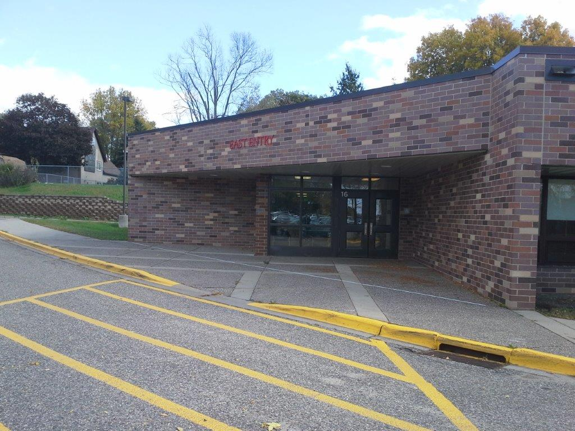

* Please do not park or stop in the driveway.

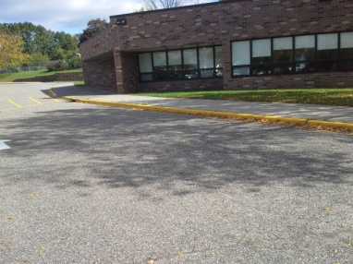 + C:\Program Files (x86)\Microsoft Office\MEDIA\CAGCAT10\j0183328.wmf = 

 +   